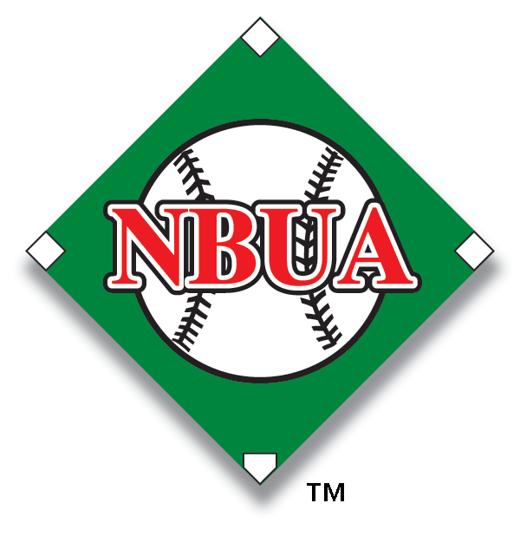
Expectations of "C" Tier Umpires
Appearance
o Clean and pressed uniform every game
o Arrives on time every game (45 min before game time)
o Shined shoes
o Proper wearing and use of equipment (mask / helmet, indicator)

Mechanics
o Knowledge of 1-Man mechanics
· Proper positioning for every play
o Develop knowledge of strike zone
o Begin understanding and proper application of 2-Man mechanics
Communications
o Begin to consistently vocalize called balls and strikes
o Begin to consistently vocalize safes and outs
o Begin to consistently vocalize catch and no catch (when necessary)
o Begin to consistently signal and vocalize situation when working with a partner
Rules Knowledge
o Have a fundamental knowledge of differences between high school and professional rules
o Know and how to enforce the infield fly rule
o Begin to know how to identify and enforce the balk rule
- Have a basic understanding of how to identify both Interference & Obstruction rules
Attitude
o Begin to learn what comments to ignore and which comments require a response
o Conduct yourself in a professional manner
o Be able to accept constructive criticism

